1. Which KPIs would you use to measure the performance of our app?

* Revenue
* Order_quantity_accepted
* No of user

a. Did our business grow

1.with ask as

(select *,(order_quantity_accepted * rate) as revenue from sales_ord join sales_orders_items on fk_order_id=order_id)

select sales_order_status,sum(order_quantity_accepted * rate) as revenue, creation_time from ask where sales_order_status like "shipped"

group by sales_order_status,creation_time;

ans : yes

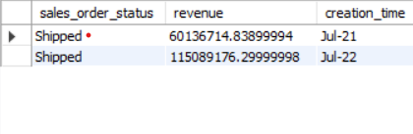

b. Does our app perform better now?

2.with ask as

(select *,(order_quantity_accepted * rate) as revenue from sales_ord join sales_orders_items on fk_order_id=order_id)

select sum(order_quantity_accepted) as order_quantity_accepted ,creation_time from ask group by creation_time ;

ans: yes

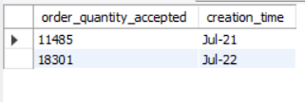

c. Did our user base grow

5.select count(user_id) as user_cnt,login_time from login_logs group by login_time

Ans: yes

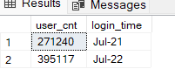

3. What are our top-selling products in each of the two years? Can you draw some insight from this?

with ask as

(select *,(order_quantity_accepted * rate) as revenue from sales_ord join sales_orders_items on fk_order_id=order_id)

select fk_product_id ,max(revenue) as revan ,creation_time from ask group by creation_time ;

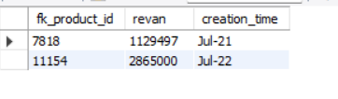

4. Looking at July 2021 data, what do you think is our biggest problem and how would you recommend fixing it?

.with ask as

(select *,(order_quantity_accepted * rate) as revenue from sales_ord join sales_orders_items on fk_order_id=order_id)

select order_id,count(order_id),sales_order_status,creation_time from ask where sales_order_status like 'rejected'

group by sales_order_status,creation_time;

ans : got lot of rejected order compare to 2022

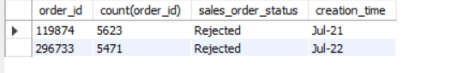

5. Does the login frequency affect the number of orders made?

5. select order_quantity_accepted as order_accepted , count(user_id) ,count(login_time) from login_logs join sales_orders on user_id = fk_buyer_id join sales_orders_items on order_id = fk_order_id group by user_id

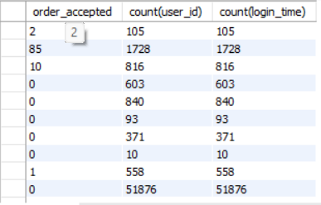

Ans;yes login frequency affect the number of order made